21.94: The electric field in the x-direction cancels the left and right halves of the semicircle. The remaining y-component points in the negative y-direction. The charge per unit length of the semicircle is:
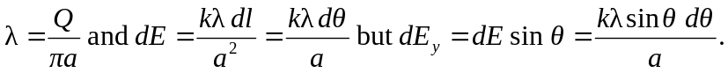
So,

